**Código Completo**

create database LojaCDExBD

use LojaCDExBD

create table Cds(

CodigoCd int primary key,

Nome_Cd varchar(50) not null,

DataCompra Date not null,

ValorPago decimal(8,2) not null,

LocalCompra varchar(40) not null,

Album varchar(3) not null

)

insert into Cds values (1, 'Never', '16/04/2024', 115.00, 'Loja de Disco Principal', 'Sim');

insert into Cds values (2, 'California Love', '16/04/2024', 125.00, 'Loja de Disco Principal', 'Sim');

insert into Cds values (3, 'Run', '16/04/2024', 135.00, 'Loja de Disco Principal', 'Não');

insert into Cds values (4, 'Hotel in New York', '16/04/2024', 145.00, 'Loja de Disco Principal', 'Sim');

insert into Cds values (5, 'Boutique', '16/04/2024', 105.00, 'Loja de Disco Principal', 'Não');

select * from Cds

select Nome_cd, DataCompra from Cds order by Nome_Cd

select Nome_cd, DataCompra from Cds order by DataCompra desc

select Nome_cd, DataCompra, ValorPago from Cds order by ValorPago desc

select sum(ValorPago) as TotalGasto from Cds

select Nome_Cd from Cds where LocalCompra = 'Submarino'

select * from Cds where Album = 'Sim'

select avg(ValorPago) as MediaPrecosCD from Cds

create table Musicas(

CodigoCd int

foreign key (CodigoCd) references Cds,

Numero_Musica Int,

Nome_Musica varchar(50) not null,

Artista varchar (50) not null,

Tempo varchar (15) not null

)

insert into Musicas values (1, '1', 'Back', 'Marieh Blonde', '0:3:42');

insert into Musicas values (1, '2', 'The Payback', 'Marieh Blonde', '0:4:48');

insert into Musicas values (1, '3', 'Beat', 'Marieh Blonde', '0:3:18');

insert into Musicas values (2, '1', 'Natural', 'José Pedro', '0:5:36');

insert into Musicas values (2, '2', 'Get Up', 'José Pedro', '0:4:01');

insert into Musicas values (2, '3', 'Hey Marieh', 'José Pedro', '0:2:56');

insert into Musicas values (3, '1', 'Rock', 'Jimi Dylan', '0:6:46');

insert into Musicas values (3, '2', 'Solo Guitar', 'Jimi Dylan', '0:8:49');

insert into Musicas values (3, '3', 'This is EUA', 'Jimi Dylan', '0:3:22');

insert into Musicas values (4, '1', 'I love You', 'The Eagles', '0:4:51');

insert into Musicas values (4, '2', 'Two Loves', 'The Eagles', '0:6:24');

insert into Musicas values (4, '3', 'Red Heart', 'The Eagles', '0:3:55');

insert into Musicas values (5, '1', 'Bloom', 'The One', '0:3:33');

insert into Musicas values (5, '2', 'Dance', 'The One', '0:4:24');

insert into Musicas values (5, '3', 'The Dark', 'The One', '0:5:15');

select * from Musicas where CodigoCd = 1

select Nome_Musica, Artista from Musicas

select Numero_Musica, Nome_Musica, Tempo from Musicas where CodigoCd = 5 order by Numero_Musica

select count(*) as QtddMusicas from Musicas

select Nome_Musica from Musicas where Artista = 'José Pedro'

select Nome_Musica from Musicas order by Nome_Musica

**Tabelas**

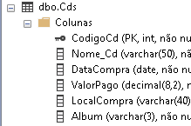

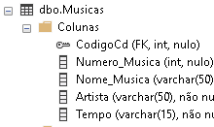

**MER**

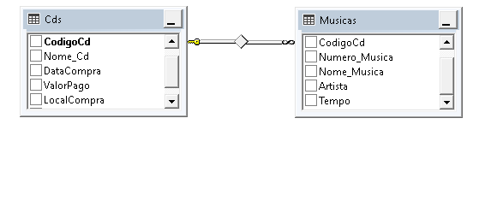

**1.** select * from Cds

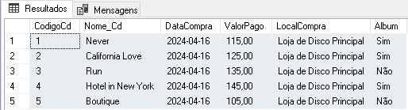

**2.** select Nome_cd, DataCompra from Cds order by Nome_Cd

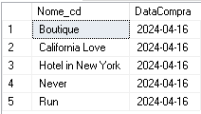

**3.** select Nome_cd, DataCompra from Cds order by DataCompra desc

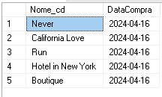

**4.** select Nome_cd, DataCompra, ValorPago from Cds order by ValorPago desc

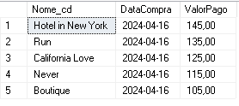

**5.** select sum(ValorPago) as TotalGasto from Cds



**6.** select * from Musicas where CodigoCd = 1

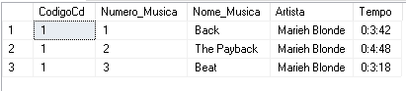

**7.** select Nome_Musica, Artista from Musicas

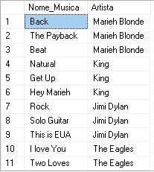

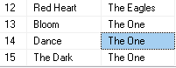

**8.** select Numero_Musica, Nome_Musica, Tempo from Musicas where CodigoCd = 5 order by Numero_Musica

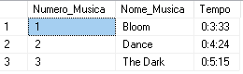

**9.** select count(*) as QtddMusicas from Musicas



**10.** select Nome_Musica from Musicas where Artista = 'José Pedro'

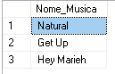

**11.** select Nome_Cd from Cds where LocalCompra = 'Submarino'

**12.** select Nome_Musica from Musicas order by Nome_Musica

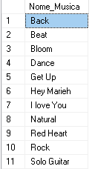

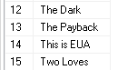

**13.** select * from Cds where Album = 'Sim'

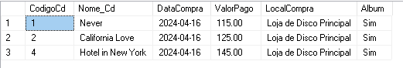

**14.** select avg(ValorPago) as MediaPrecosCD from Cds

